Ch10 - Packet Tracer Skills Integration Challenge

Topology Diagram
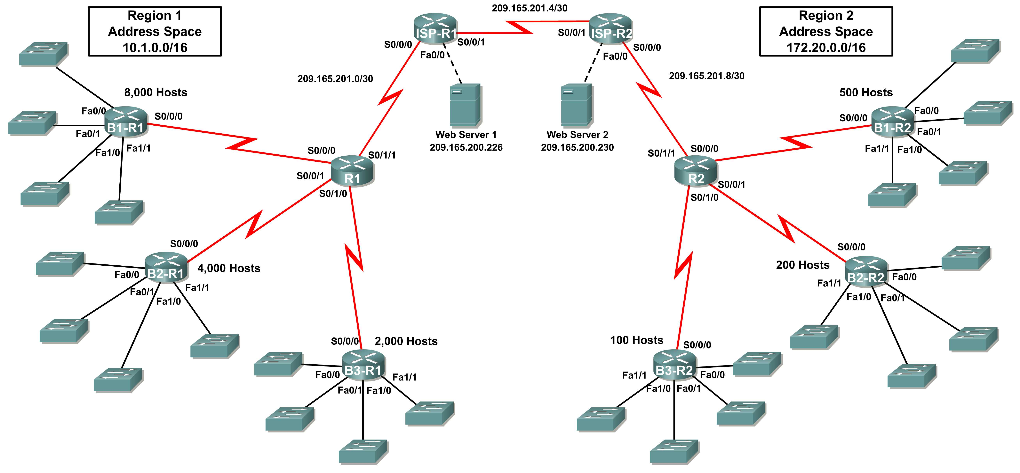

Addressing Table for R1
Device | Interface | IP Address | Subnet Mask
R1 | S0/0/0 | 10.1.64.1 | 255.255.255.252
R1 | S0/0/1 | 10.1.64.5 | 255.255.255.252
R1 | S0/1/0 | 10.1.64.9 | 255.255.255.252
R1 | S0/1/1 | 209.165.201.2 | 255.255.255.252
B1-R1 | Fa0/0 | 10.1.0.1 | 255.255.248.0
B1-R1 | Fa0/1 | 10.1.8.1 | 255.255.248.0
B1-R1 | Fa1/0 | 10.1.16.1 | 255.255.248.0
B1-R1 | Fa1/1 | 10.1.24.1 | 255.255.248.0
B1-R1 | S0/0/0 | 10.1.64.2 | 255.255.255.252
B2-R1 | Fa0/0 | 10.1.32.1 | 255.255.252.0
B2-R1 | Fa0/1 | 10.1.36.1 | 255.255.252.0
B2-R1 | Fa1/0 | 10.1.40.1 | 255.255.252.0
B2-R1 | Fa1/1 | 10.1.44.1 | 255.255.252.0
B2-R1 | S0/0/0 | 10.1.64.6 | 255.255.255.252
B3-R1 | Fa0/0 | 10.1.48.1 | 255.255.254.0
B3-R1 | Fa0/1 | 10.1.50.1 | 255.255.254.0
B3-R1 | Fa1/0 | 10.1.52.1 | 255.255.254.0
B3-R1 | Fa1/1 | 10.1.54.1 | 255.255.254.0
B3-R1 | S0/0/0 | 10.1.64.10 | 255.255.255.252
ISP-R1 | S0/0/0 | 209.165.201.1 | 255.255.255.252
ISP-R1 | S0/0/1 | 209.165.201.5 | 255.255.255.252
ISP-R1 | Fa0/0 | 209.165.200.225 | 255.255.255.252
Web Server 1 | NIC | 209.165.200.226 | 255.255.255.252

Addressing Table for R2
Device | Interface | IP Address | Subnet Mask
R2 | S0/0/0 | 172.20.4.1 | 255.255.255.252
R2 | S0/0/1 | 172.20.4.5 | 255.255.255.252
R2 | S0/1/0 | 172.20.4.9 | 255.255.255.252
R2 | S0/1/1 | 209.165.201.10 | 255.255.255.252
B1-R2 | Fa0/0 | 172.20.0.1 | 255.255.255.128
B1-R2 | Fa0/1 | 172.20.0.129 | 255.255.255.128
B1-R2 | Fa1/0 | 172.20.1.1 | 255.255.255.128
B1-R2 | Fa1/1 | 172.20.1.129 | 255.255.255.128
B1-R2 | S0/0/0 | 172.20.4.2 | 255.255.255.252
B2-R2 | Fa0/0 | 172.20.2.1 | 255.255.255.192
B2-R2 | Fa0/1 | 172.20.2.65 | 255.255.255.192
B2-R2 | Fa1/0 | 172.20.2.129 | 255.255.255.192
B2-R2 | Fa1/1 | 172.20.2.193 | 255.255.255.192
B2-R2 | S0/0/0 | 172.20.4.6 | 255.255.255.252
B3-R2 | Fa0/0 | 172.20.3.1 | 255.255.255.224
B3-R2 | Fa0/1 | 172.20.3.33 | 255.255.255.224
B3-R2 | Fa1/0 | 172.20.3.65 | 255.255.255.224
B3-R2 | Fa1/1 | 172.20.3.97 | 255.255.255.224
B3-R2 | S0/0/0 | 172.20.4.10 | 255.255.255.252
ISP-R2 | S0/0/0 | 209.165.201.6 | 255.255.255.252
ISP-R2 | S0/0/1 | 209.165.201.9 | 255.255.255.252
ISP-R2 | Fa0/0 | 209.165.200.229 | 255.255.255.252
Web Server 2 | NIC | 209.165.200.230 | 255.255.255.252

Objectives
- Design and document an addressing scheme based on requirements.
- Apply a basic configuration to the devices.
- Configure static routing between ISP routers.
- Configure EIGRP routing in Region 1 and RIPv2 routing Region 2.
- Disable routing updates on appropriate interfaces.
- Configure and redistribute default routes.
- Verify full connectivity between all devices in the topology.
Task 1: Design and Document an Addressing Scheme.
Step 1: Design an addressing scheme.
Using the topology and the following requirements, design an addressing scheme:
- The WAN links between R1 and R2 and their respective ISP routers are already configured. Also, the links between the ISPs and the Web Servers are already configured.
- The address space for Region 1 is 10.1.0.0/16. Each branch router (B1-R1, B2-R1, and B3-R1) should be allotted address space based on the following requirements. Starting with the largest requirement, assign address space to each router
    - B1-R1 needs space for 8,000 hosts 10.1.0.0 - 10.1.31.255 /19
    - B2-R1 needs space for 4,000 hosts 10.1.32.0 - 10.1.47.255 /20
    - B3-R1 needs space for 2,000 hosts 10.1.48.0 - 10.1.55.255 /21
- Divide the address space for each branch router into four equal subnets. Record the subnets in the table below.
Router | Subnet  Number | Subnet Address
B1-R1 Fa0/0 | 0 | 10.1.0.0 - 10.1.7.255 /21
B1-R1 Fa0/1 | 1 | 10.1.8.0 - 10.1.15.255 /21
B1-R1 Fa1/0 | 2 | 10.1.16.0 - 10.1.23.255 /21
B1-R1 Fa1/1 | 3 | 10.1.24.0 - 10.1.31.255 /21

Router | Subnet  Number | Subnet Address
B2-R1 Fa0/0 | 0 | 10.1.32.0 - 10.1.35.255 /22
B2-R1 Fa0/1 | 1 | 10.1.36.0 - 10.1.39.255 /22
B2-R1 Fa1/0 | 2 | 10.1.40.0 - 10.1.43.255 /22
B2-R1 Fa1/1 | 3 | 10.1.44.0 - 10.1.47.255 /22

Router | Subnet  Number | Subnet Address
B3-R1 Fa0/0 | 0 | 10.1.48.0 - 10.1.49.255 /23
B3-R1 Fa0/1 | 1 | 10.1.50.0- 10.1.51.255 /23
B3-R1 Fa1/0 | 2 | 10.1.52.0- 10.1.53.255 /23
B3-R1 Fa1/1 | 3 | 10.1.54.0- 10.1.55.255 /23

- For the WANs in Region 1, subnet the address space 10.1.64.0/28. Record the subnets in the table below.
Router | Subnet  Number | Subnet Address
B1-R1 <--> R1 | 0 | 10.1.64.0 - 10.1.64.3 /30
B2-R1 <--> R1 | 1 | 10.1.64.4 - 10.1.64.7 /30
B3-R1 <--> R1 | 2 | 10.1.64.8 - 10.1.64.11 /30

- The address space for Region 2 is 172.20.0.0/16. Each branch router (B1-R2, B2-R2, and B3-R2) should be allotted address space based on the following requirements. Starting with the largest requirement, assign address space to each router
    - B1-R2 needs space for 500 hosts 172.20.0.0 - 172.20.1.255 /23
    - B2-R2 needs space for 200 hosts 172.20.2.0 - 172.20.2.255 /24
    - B3-R2 needs space for 100 hosts 172.20.3.0 - 172.20.3.127 /25
- Divide the address space for each branch router into four equal subnets. Record the subnets in the table below.
Router | Subnet  Number | Subnet Address
B1-R2 Fa0/0 | 0 | 172.20.0.0 - 172.20.0.127 /25
B1-R2 Fa0/1 | 1 | 172.20.0.128 - 172.20.0.255 /25
B1-R2 Fa1/0 | 2 | 172.20.1.0 - 172.20.1.127 /25
B1-R2 Fa1/1 | 3 | 172.20.1.128 - 172.20.1.255 /25

Router | Subnet  Number | Subnet Address
B2-R2 Fa0/0 | 0 | 172.20.2.0 - 172.20.0.63 /26
B2-R2 Fa0/1 | 1 | 172.20.2.64 - 172.20.0.127 /26
B2-R2 Fa1/0 | 2 | 172.20.2.128 - 172.20.0.191 /26
B2-R2 Fa1/1 | 3 | 172.20.2.192 - 172.20.0.255 /26

Router | Subnet  Number | Subnet Address
B3-R2 Fa0/0 | 0 | 172.20.3.0 - 172.20.3.31 /27
B3-R2 Fa0/1 | 1 | 172.20.3.32 - 172.20.3.63 /27
B3-R2 Fa1/0 | 2 | 172.20.3.64 - 172.20.3.95 /27
B3-R2 Fa1/1 | 3 | 172.20.3.96 - 172.20.3.127 /27

- For the WANs in Region 2, subnet the address space 172.20.4.0/28. B1-R2 to R2 receives the first subnet, B2-R2 to R2, the second subnet, and B3-R2 the third, Record the subnets.
Router | Subnet  Number | Subnet Address
B1-R2 <--> R2 | 0 | 172.20.4.0 - 172.20.4.3 /30
B2-R2 <--> R2 | 1 | 172.20.4.4 - 172.20.4.7 /30
B3-R2 <--> R2 | 2 | 172.20.4.8 - 172.20.4.11 /30

Step 2: Document the addressing scheme.
- Optional: On the topology, label each subnet. To save space, use only the last two octets since only these octets change.
- Use the table provided in the printed instructions to document the IP addresses and subnet masks. Assign the first IP address to the router interface.
- For the WAN links, assign the first IP address to R1 and R2 for links to each router’s perspective B1, B2, and B3 routers.
Task 2: Apply a Basic Configuration.
Using your documentation, configure the routers with basic configurations including addressing. Use cisco as the line passwords and class as the secret password. Use 64000 as the clock rate.
Task 3: Configure Static Routing Between ISP Routers.
Each ISP router already has two static routes to the other ISP router’s directly connected WANs. Implement static routing on each ISP router to insure connectivity between the two regions.
Task 4: Configure EIGRP Routing in Region 1 and RIPv2 Routing Region 2.
Step 1: Configure EIGRP routing in Region 1.
Configure all routers in Region 1 (R1, B1-R1, B2-R1, and B3-R1) with EIGRP as the dynamic routing protocol.
- Use 1 as the process ID for EIGRP
- Disable automatic summarization
- Manually summarize routes advertised by the branch routers to R1 so that only one route is sent (NOTE: The current version of Packet Tracer allows the configuration of the summary command. However, the routing tables will still display as if summarization has not been configured. This is a known bug that will be addressed in a future release.)
- Configure the hello intervals on the branch routers to 30 seconds.
Step 2: Configure RIPv2 routing Region 2.
Configure all routers in Region 2 (R2, B1-R2, B2-R2, and B3-R2) with RIPv2 as the dynamic routing protocol. Disable automatic summarization.
Task 5: Disable Routing Updates on Appropriate Interfaces.
Routing updates do not need to be sent out all the router interfaces. Disable routing updates on appropriate interfaces.
Task 6: Configure and Redistribute Default Routes.
- Packet Tracer does not yet support the redistribution of a static default routes with EIGRP. Therefore, you must configure all routers in Region 1 with a default route. Use the exit interface argument.
- Configure the appropriate router in Region 2 with a default route. Then configure that router to redistribute the default route to all other routers in the region.
Task 7: Verify Full Connectivity Between all Devices in the Topology.
Step 1: Test connectivity.
- You should now have end-to-end connectivity. Use ping to test connectivity across the network. Each router should be able to ping all other router interfaces and both Web Servers.
- Troubleshoot until pings are successful.
Step 2: Examine the configuration.
Use verification commands to make sure your configurations are complete.

